Safe Working Practice

QCTO: Occupational Health, Safety Quality Practitioner Qualification – NQF Level 5
ISO NET (Pty) Ltd
Learner Guide

226302001-KM-01-KT-07


COURSE CONTENTS:

SAFE WORK PRACTICES
Provide Clear Expectations
Give People The Opportunity To Use Their Skills
Support Your Team
Encourage People To Contribute Ideas And Get Involved In Decisions
Encourage Feedback and Recognition
Do people have fun at work?
Encourage learning and development
Create a great workplace from an employee’s view
Reducing error and influencing behaviour
What are ‘human factors’?
Why should I be interested in human factors issues at work?

How do I know if these problems exist in my organisation?
Isn’t it just about people ‘taking more care’?
Isn’t this going to be costly?
Should I seek the views of the workforce and their representatives?
What kind of control measures are possible?
Understanding human failure
Human failure and accidents
The human contribution to accidents
The consequences of human failures can be immediate or delayed.
Investigating the causes of accidents
Causes of human failure
There are different types of human failures: errors and violations (see Figure 2)
Errors fall into three categories: slips, lapses and mistakes.
Types of workplace rules
Why subordinates do not do what they are supposed to do
General risk control rules
General risk control rules
Specialised work rules
Specialised work rules

Pipe Fitter Rules
Develop and manage workplace rules
Prepare the rules
- Apply the “principle of involvement”
- Keep rules to a minimum
- Apply the “KISS” principle
- Keep rules as practical as possible
- Give reasons for rules
- Review existing rules
Present the rules
- Employee distribution
- “Show and Tell”
- Test Their Knowledge of Rules
Enforce the rules
Reinforce the rules
- Group meeting discussions
- Personal contact reminders
- Displaying
- Contests and awards
- Formal reviews
Leadership example
Work permit system
Purpose of a work permit
Description of a work permit system
Explanation of terms
Aim of a work permit system
Reasons for issuing a work permit
- To aid communication between the people involved in the work.
- To have a written record or insurance policy for the people involved.
Types of work that require permits
Permit administration systems
Motivation for a work permit system
Essential features of the work permit system
Personal protective equipment systems
Identification of PPE needs
Key points for improved standards
- Standards
- Selection
- Training
- Reinforcement of Use
- Compliance Checks
Records and analysis
Lockout and tagout
Symbolic safety signs
Geometric shape
Types of information conveyed by signs
Pictogram
Warning (be careful)
Examples of warning signs
Prohibitory (do not)
Examples of Prohibitory signs
Mandatory (must use)
Examples of mandatory signs
Informatory (general information)
General Information
Informatory (fire equipment)
Examples of mandatory signs
Examples of information, general signs
Examples of information, fire fighting signs
Examples of prohibitory signs

SAFE WORK PRACTICES
A happy workplace is a huge asset. In such places, something happens that transcends policies and practices. It isn’t what the companies are doing; it is how their leaders are doing it. Best workplace practices include the day to day relationships that the employees experience, and not a checklist of policies, programmes and benefits.
Provide Clear Expectations
People get frustrated and demotivated when they don’t know exactly what is expected of them. It starts with the CEO, and is important for every level of leadership in a business. Create a culture where you clearly state:
• Vision, Goals, Roles & Values
• Results, Quality Standards, Timelines, Priorities
• Written lists of agreed actions and outcomes
Encourage your team to ask questions. Ensure the communication is clear, specific and without any doubts.
Give People The Opportunity To Use Their Skills
Frustration and boredom are counterproductive so you need to align jobs with people with the right skills. Uncover the special skills people could be using, and experiment with projects and roles to get the alignment right. You need to recognise talent and use it. If a person is recruited for a role and then not given the opportunity to use their skills, they will not deliver their best work and may leave.
Support Your Team
There are many workplaces where managers don’t care about their people and make no effort to show interest. This is bad word of mouth. One should know about their staff: what is happening in their lives, what motivates them, and offering assistance when they are overloaded.
Encourage People To Contribute Ideas And Get Involved In Decisions
Involving people, asking their opinions and listening to their advice and feedback makes a huge difference to them and will provide an environment that is open to innovation and improvements.
Encourage Feedback and Recognition
Managers are leaders without the title, so being open to feedback, and giving positive and constructive feedback is a great way to establish an honest open feedback culture. Encourage day-to-day feedback discussions and the establishment of recognition systems.

Do people have fun at work?
Everyone needs a downtime from work. This could be a casual day, afternoon break with a difference like culturally focused food, trivia competitions, team outing, etc. You need to find a way to build this in as a regular part of your workplace.
Encourage learning and development
You need to promote learning, and opportunities to develop new skills. People need to know there is the time to do it, and a positive emphasis on gaining new skills and learning from mistakes. Learning is about developing new skills and improving the ones you have. Give people the opportunity to continuously grow, learn, explore, innovate and you will have the best team ever!
Create a great workplace from an employee’s view:
From the Employee’s perspective, a great workplace is one where they:
- Trust the people they work for
- Have pride in what they do
- Enjoy the people they work with
Trust is the defining principle of great workplaces — created through management’s credibility, the respect with which employees feel they are treated, and the extent to which employees expect to be treated fairly. The degree of pride and levels of authentic connection and camaraderie employees feel with one are additional essential components.
Reducing error and influencing behaviour

What are ‘human factors’?
The HSE definition is: ‘Human factors refer to environmental, organisational and job factors, and human and individual characteristics which influence behaviour at work in a way which can affect health and safety’. A simple way to view human factors is to think about three aspects: the job, the individual and the organisation and how they impact on people’s health and safety-related behaviour.

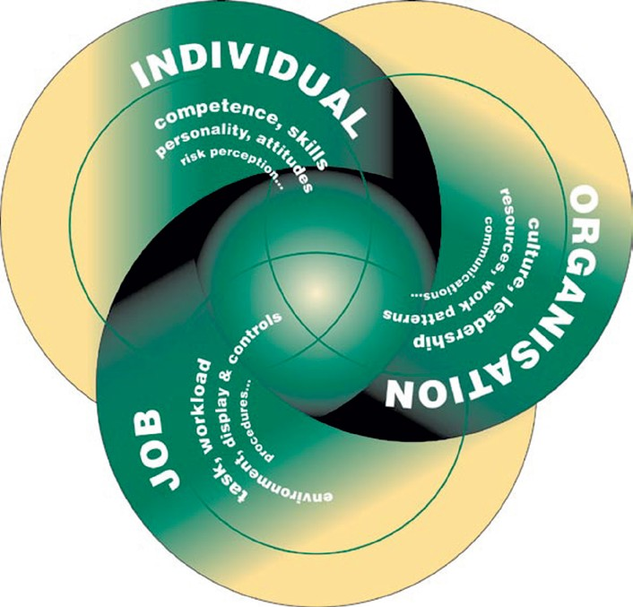

The job - Tasks should be designed in accordance with ergonomic principles to take into account limitations and strengths in human performance. Matching the job to the person will ensure that they are not overloaded and that the most effective contribution to the business results. Physical match includes the design of the whole workplace and working environment.

Mental match involves the individual’s information and decision-making requirements, as well as their perception of the tasks and risks. Mismatches between job requirements and people’s capabilities provide the potential for human error.

The individual - People bring to their job personal attitudes, skills, habits and personalities which can be strengths or weaknesses depending on the task demands. Individual characteristics influence behaviour in complex and significant ways.

Their effects on task performance may be negative and may not always be mitigated by job design. Some characteristics such as personality are fixed and cannot be changed. Others, such as skills and attitudes, may be changed or enhanced.

The organisation - Organisational factors have the greatest influence on individual and group behaviour, yet they are often overlooked during the design of work and during investigation of accidents and incidents. Organisations need to establish their own positive health and safety culture.

The culture needs to promote employee involvement and commitment at all levels, emphasising that deviation from established health and safety standards is not acceptable.

Figure 1 lists some of the key issues for each area. By thinking about these aspects you are asking questions about:

- What are people being asked to do and where (the task and its characteristics)?
- Who is doing it (the individual and their competence)?
- Where are they working (the organisation and its attributes)?

Why should I be interested in human factors issues at work?

Careful consideration of human factors at work can reduce the number of accidents and cases of occupational ill-health. It can also pay dividends in terms of a more efficient and effective workforce.

Accidents can occur through people’s involvement with their work. As technical systems have become more reliable, the focus has turned to human causes of accidents. It is estimated that up to 80% of accidents may be attributed, at least in part, to the actions or omissions of people.

This is not surprising since people are involved throughout the life cycle of an organisation, from design through to operation, maintenance, management and demolition. Many accidents are blamed on the actions or omissions of an individual who was directly involved in operational or maintenance work.

This typical but short-sighted response ignores the fundamental failures which led to the accident. These are usually rooted deeper in the organisation’s design, management and decision-making functions.

Work has an impact on people’s health as well as on their safety. A positive work experience leads to job satisfaction and contributes to physical and mental well- being. Well-designed tasks and working environments that suit people’s individual skills and capabilities can help here.

Physical health problems can result from lost- time injuries such as slips and falls, and from manual handling problems. Mental well-being can be affected if someone witnesses a traumatic event, suffers bullying or violence at work, or experiences stress at work.

How do I know if these problems exist in my organisation?

You will know you need to think about human factors issues at work by looking out for some relevant indicators like those given in Box A.

Accidents involving staff, contractors or visitors where ‘human error’ is given as a cause
Occupational health reports of mental or physical ill-health High absenteeism or sickness rates
High staff turnover levels
Low level of, or changes in, compliance with health and safety rules Behaviour or performance issues identified in risk assessments Complaints from staff about working conditions or job design

Isn’t it just about people ‘taking more care’?

No. It is quite wrong to believe that telling people to take more care is the answer to these problems. While it is reasonable to expect people to pay attention and take care at work, relying on this is not enough to control risks. Box B shows what can happen if complacency about risks is combined with a belief that ‘taking care’ is a suitable control measure.

A farm worker was crushed under the wheel of a manure spreader which was being reversed between a building and a retaining wall for a distance of about ten metres.

The driver was asked by the farm worker to move the tractor and spreader to allow access for cattle into a yard. He agreed to move it and intended to reverse it into another yard. When he got into the tractor, the farm worker was standing by the nearside of the tractor. He started the engine and looked over his right shoulder and reversed.

After four or five metres he heard a scream and found the worker lying under the nearside of the spreader in front of the wheel. A witness had apparently seen the farm worker fall under the wheel.

The ground was very muddy and the soles of the farm worker’s boots had become smooth. The tractor was large and not fitted with rear view mirrors as it was not used on the highway.

Everyone (farm managers and employees) were complacent about the risks in reversing equipment and believed that if everyone ‘took care’ no accidents would happen. In this case there were a number of steps which could have been taken to reduce the risks, such as the provision of mirrors on the tractor, and checking and replacing of boots.

However, these steps would not be implemented unless farm managers and employees took a more positive attitude to risk reduction.

Don’t be discouraged by the breadth of issues that are covered by human factors. This guidance will provide you with practical information to help you start to manage human factors in your organisation. In particular it should help you to make progress in addressing human factors in four main areas:

- during risk assessments;
- when analysing incidents, accidents and near misses;
- in design and procurement; and
- in certain aspects of day-to-day health and safety management.

It is a continual challenge to manage the risks to and from people at work so that they remain safe and healthy. Improving health and safety cannot rely just on improvements in technical and system factors. You need to tackle some of the important ‘people’ issues too.

Isn’t this going to be costly?

Many improvements will be at minimal cost and the ideas may already exist in your organisation. The set of case studies in Chapter 6 show you how straightforward many human factors changes can be. Even relatively small changes to tasks and the working environment can improve health and safety as well as productivity and quality.

Should I seek the views of the workforce and their representatives?

Yes, this is vital. Both safety representatives and other staff know about their job and working conditions. They will have insights into how this impacts on their health and safety. They will be able to help you to identify key issues and may already have suggestions for improvements.

You will need to prioritise these issues and allocate appropriate resources to carry through the actions. Proper planning before implementing changes includes consulting the workforce and their representatives. This will usually lead to any changes being introduced more easily and accepted more readily. Afterwards you will also need to check and review that the changes have been effective.

What kind of control measures are possible?

A range of control measures are available including: workplace precautions, risk control systems, and management arrangements.

Adequate workplace precautions have to be provided and maintained to prevent harm to the people at risk. These precautions include: procedures and warnings, safe systems of work, controls on equipment, alarms, safety instructions, communications arrangements, and machine guards. All of these need to be designed with the human in mind to make sure that they are used correctly and reliably. Ergonomic changes to the task and the working environment also help to reduce risks and can improve the physical and mental well-being of the workforce.

Risk control systems are the basis for ensuring that adequate workplace precautions are provided and maintained. Most of the activities where risk control systems are needed will involve people, eg maintenance, routine and non-routine operations, recruitment and selection, demolition, dealing with emergencies. Looking at ways of improving the human factors aspects of these activities, eg through training, selection, and job design, will enhance risk control.

A set of management processes is necessary to organise, plan, control and monitor the design and implementation of the risk control systems. HSE’s publication Successful health and safety management1 provides advice in this area.

KEY MESSAGES

Consideration of ‘human factors’ is a key ingredient of effective health and safety management. It involves:

■ thinking about relevant job, individual and organisational aspects;
■ addressing human factors in risk assessment, during accident investigation, in design and procurement and in day-to-day operations;
■ involving the workforce and their representatives; and
■ selecting from a range of effective control measures.

Understanding human failure

Human failure and accidents

Over the last 20 years we have learnt much more about the origins of human failure. We can now challenge the commonly held belief that incidents and accidents are the result of a ‘human error’ by a worker in the ‘front line’. Attributing incidents to ‘human error’ has often been seen as a sufficient explanation in itself and something which is beyond the control of managers.

This view is no longer acceptable to society as a whole. Organisations must recognise that they need to consider human factors as a distinct element which must be recognised, assessed and managed effectively in order to control risks.

Accident, industry and date | Consequences | Human contribution and other causes
Three Mile Island | Serious damage | Operators failed to diagnose a stuck open valve due to
Nuclear industry | to core of nuclear | poor design of control panel, distraction of 100 alarms
1979 | reactor. | activating, inadequate operator training. Maintenance
 |  | failures had occurred before but no steps had been
 |  | taken to prevent them recurring.
King’s Cross Fire | A fire at this | A discarded cigarette probably set fire to grease
Transport sector | underground station | and rubbish underneath one of the escalators.
1987 | in London killed 31 | Organisational changes had resulted in poor escalator
 | people. | cleaning. The fire took hold because of the wooden
 |  | escalator, the failure of water fog equipment and
 |  | inadequate fire and emergency training of staff. There
 |  | was a culture which viewed fires as inevitable.
Clapham Junction | 35 people died and | Immediate cause was a signal failure caused by
Transport sector | 500 were injured in a | a technician failing to isolate and remove a wire.
1988 | triple train crash. | Contributory causes included degradation of working
 |  | practices, problems with training, testing quality and
 |  | communications standards, poor supervision. Lessons
 |  | not learnt from past incidents. No effective system for
 |  | monitoring or limiting excessive working hours.
Herald of Free | This roll-on roll- | Immediate cause was the failure to close the bow doors
Enterprise | off ferry sank in | before leaving port. No effective reporting system to
Transport sector | shallow water off | check the bow doors. Formal inquiry reported that the
1987 | Zeebrugge killing | company was ‘infected with the disease of sloppiness’.
 | 189 passengers and | Commercial pressures and friction between ship and shore
 | crew. | management had led to safety lessons not being learnt.
Union Carbide Bhopal, | The plant released a | The leak was caused by a discharge of water into a
India | cloud of toxic methyl | storage tank. This was the result of a combination of
Chemical processing | isocynate. Death toll | operator error, poor maintenance, failed safety systems
1984 | was 2500 and over | and poor safety management.
1984 | one quarter of the | and poor safety management.
1984 | city’s population was | and poor safety management.
1984 | affected by the gas. | and poor safety management.

Accident, industry and date | Consequences | Human contribution and other causes
Space Shuttle | An explosion shortly | An O-ring seal on one of the solid rocket boosters split
Challenger | after lift-off killed all | after take-off releasing a jet of ignited fuel. Inadequate
Aerospace | seven astronauts on | response to internal warnings about the faulty seal
1986 | board. | design. Decision taken to go for launch in very cold
 |  | temperature despite faulty seal. Decision-making result
 |  | of conflicting scheduling/safety goals, mindset, and
 |  | effects of fatigue.
Piper Alpha | 167 workers died in | Formal inquiry found a number of technical and
Offshore | the North Sea after a | organisational failures. Maintenance error that
1988 | major explosion and | eventually led to the leak was the result of inexperience,
 | fire on an offshore | poor maintenance procedures and poor learning
 | platform. | by the organisation. There was a breakdown in
 |  | communications and the permit-to-work system at shift
 |  | changeover and safety procedures were not practised
 |  | sufficiently.
Chernobyl | 1000 MW Reactor | Causes are much debated but Soviet investigative
Nuclear industry | exploded releasing | team admitted ‘deliberate, systematic and numerous
1986 | radioactivity over | violations’ of safety procedures by operators.
 | much of Europe.
 | Environmental and
 | human cost.
Texaco Refinery, | An explosion on the | The incident was caused by flammable hydrocarbon
Milford Haven | site was followed by | liquid being continuously pumped into a process vessel
Chemical processing | a major hydrocarbon | that had its outlet closed. This was the result of a
1994 | fire and a number | combination of: an erroneous control system reading
1994 | of secondary fires. | of a valve state, modifications which had not been
1994 | There was severe | fully assessed, failure to provide operators with the
1994 | damage to process | necessary process overviews and attempts to keep the
1994 | plant, buildings and | unit running when it should have been shut down.
1994 | storage tanks. 26 | unit running when it should have been shut down.
1994 | people sustained | unit running when it should have been shut down.
1994 | injuries, none serious. | unit running when it should have been shut down.

It is all too easy to provide examples of accidents where ‘human error’ has given rise to a major accident with loss of life and injuries. Table 1 illustrates how the failure of people at many levels within an organisation can contribute to a major disaster.

For many of these major accidents the human failure was not the sole cause but one of a number of causes, including technical and organisational failures, that led to the final outcome. Remember that many ‘everyday’ minor accidents and near misses also involve human failures.

We all make errors irrespective of how much training and experience we possess or how motivated we are to do it right. Failures are more serious for jobs where the consequences of errors are not protected. However, errors can occur in all tasks, not just those which are called safety-critical.

The human contribution to accidents

People can cause or contribute to accidents (or mitigate the consequences) in a number of ways:

- Through a failure a person can directly cause an accident. However, people tend not to make errors deliberately. We are often ‘set up to fail’ by the way our brain processes information, by our training, through the design of equipment and procedures and even through the culture of the organisation we work for.
- People can make disastrous decisions even when they are aware of the risks. We can also misinterpret a situation and act inappropriately as a result. Both of these can lead to the escalation of an incident.
- On the other hand we can intervene to stop potential accidents. Many companies have their own anecdotes about recovery from a potential incident through the timely actions of individuals. Mitigation of the possible effects of an incident can result from human resourcefulness and ingenuity.
- The degree of loss of life can be reduced by the emergency response of operators and crew. Emergency planning and response including appropriate training can significantly improve rescue situations.

The consequences of human failures can be immediate or delayed.

Active failures have an immediate consequence and are usually made by front- line people such as drivers, control room staff or machine operators. In a situation where there is no room for error these active failures have an immediate impact on health and safety.

Latent failures are made by people whose tasks are removed in time and space from operational activities, eg designers, decision makers and managers. Latent failures are typically failures in health and safety management systems (design, implementation or monitoring). Examples of latent failures are:

- poor design of plant and equipment;
- ineffective training;
- inadequate supervision;
- ineffective communications; and
- uncertainties in roles and responsibilities.

Latent failures provide as great, if not a greater, potential danger to health and safety as active failures. Latent failures are usually hidden within an organisation until they are triggered by an event likely to have serious consequences.

Investigating the causes of accidents
After an accident involving human failure there may be an investigation into the causes and contributing factors. Very often, little attempt is made to understand why the human failures occurred. However, finding out both the immediate and the underlying causes of an accident is the key to preventing similar accidents through the design of effective control measures.

Typical examples of immediate causes and contributing factors for human failures are given in Box C. This is not a complete list and you will be able to add other causes. The HSE publication
Successful health and safety management1 gives more information on investigating accidents. Formal methods for causal analysis exist and are described in CCPS (1994).2

Causes of human failure

There are different types of human failures: errors and violations (see Figure 2)

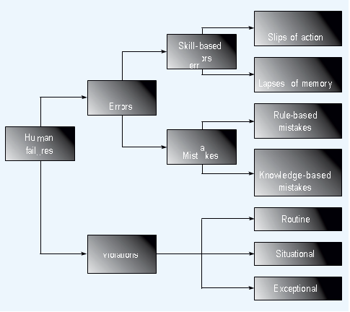

- a human error is an action or decision which was not intended, which involved a deviation from an accepted standard, and which led to an undesirable outcome.
- a violation is a deliberate deviation from a rule or procedure. Violations are discussed in detail in the section on ‘Breaking the rules’.

Errors fall into three categories: slips, lapses and mistakes.

Slips and lapses occur in very familiar tasks which we can carry out without much need for conscious attention. These tasks are called ‘skill-based’ and are very vulnerable to errors if our attention is diverted, even momentarily. Driving a car is
a typical skill-based task for many of us. Slips and lapses are the errors which are made by even the most experienced, well-trained and highly-motivated people. They often result in omitted steps in repair, maintenance, calibration or testing tasks. We need to be aware of these types of errors and try to design equipment and tasks to avoid or reduce their occurrence. We can also try to increase the opportunities to detect and correct such errors. It can be useful to make everyone aware that slips and lapses exist and to consider them during accident investigation.

Slips are failures in carrying out the actions of a task. They are described as ‘actions-not-as-planned’. Examples would be: picking up the wrong component from a mixed box, operating the wrong switch, transposing digits when copying out numbers and misordering steps in a procedure. Typical slips might include:

■ performing an action too soon in a procedure or leaving it too late;
■ omitting a step or series of steps from a task;
■ carrying out an action with too much or too little strength (eg over-torquing a bolt);
■ performing the action in the wrong direction (eg turning a control knob to the right rather than the left, or moving a switch up rather than down);
■ doing the right thing but on the wrong object (eg switching the wrong switch); and
■ carrying out the wrong check but on the right item (eg checking a dial but for the wrong value).

Types of workplace rules

Violation of established risk management rules and regulations is one of the most common causes of losses. Compliance with the rules encourages equity, consistency and accomplishment of risk control objectives.

In his book Coaching For Improved Work Performance, Ferdinand Fournies discusses his survey of 4,000 managers – from foremen to CEO’s. Below are some responses to “Why do subordinates not do what they are supposed to do?”

Why subordinates do not do what they are supposed to do

- They do not know what they are supposed to do.
- They do not know how to do it.
- They do not know why they should do it.
- There are obstacles beyond their control.
- They do not think it will work.
- They think their way is better.
- Not motivated; poor attitude.
- Personally incapable of doing it (personal limits).
- Not enough time for them to do it.
- They are working on wrong priority items.
- They think they are doing it (no feedback).
- Poor management.
- Personal problems.

The majority of reasons do not call for punishment. They call for:

- Better: management/supervision/leadership.
- Communication, motivation, training, coaching, enforcement and leadership example.

General risk control rules

Rules can be categorised as:
- General, and
- Specialised.

General rules may apply to all personnel at the worksite while others apply only to individual groups of employees.

By separating the rules, an organisation will ensure that appropriate personnel are provided with suitable and applicable information.

General risk control rules

General risk control rules are broad in nature and apply throughout the organisation. These rules may address safety, health, environment and/or quality concerns, depending on the focus of the organisation. Listed below are some examples of general rules:
- Follow instructions. Do not take chances. If you do not know, ask.
- Report immediately any condition or practice you think might cause injury to employees, damage to equipment, sub-quality or harm to the environment.
- Put everything you use in its proper place. Disorder causes injury and wastes time, energy and material. Keep your work area clean and orderly.
- Use the right tools and equipment for the task.
- Use, adjust, alter and repair equipment only when authorised.
- Whenever you or the equipment you operate is involved in an accident, regardless of how minor, report it immediately.
- Wear approved personal protective equipment as directed. Keep it in good condition.
- When lifting items, bend your knees, grasp the load firmly, then raise the load, keeping your back as straight as possible. Get help for heavy loads.
- Obey all rules, signs and instructions.

Specialised work rules

Organisations with a comprehensive task analyses and procedures program may have a reduced need for the number of specialised work rules; however, there will always be a need for a select few specialised rules related to high-risk activities.

Specialised work rules

Specialised work rules apply only to certain:
- Occupations (e.g., electrician or forklift operator).
- Areas of operation (e.g., machine shop or radiography), or
- High-risk tasks (e.g., cleaning tanks or lighting a furnace).

Below are some examples of specialised work rules.

Pipe Fitter Rules
- Protective screens must be in place prior to the commencement of welding.
- Fume extraction must be used.
- All oxygen/acetylene cylinders must be turned off and hosed down when not in use.
- All flammable items must be stored in the proper storage cabinet.
- On plant shutdowns, all welding work must stop and pipe fitter should return to the pipe shop.

Develop and manage workplace rules

In developing and managing workplace rules you should:
- Prepare the rules.
- Present the rules.
- Enforce the rules.
- Reinforce the rules.

Prepare the rules

When called upon to assist in developing rules that affect your people, use guidelines such as the following.

- Apply the “principle of involvement”
“Meaningful involvement increases motivation and support.” Find out what rules your workers think are needed. Get their ideas and suggestions. This creates ownership and authorship.

- Keep rules to a minimum
Do not try to cover everything with rules. Emphasise practices and conditions that could result in major loss. Keep these four key questions in mind:
- Is there a real need?
- Does this rule meet the need?
- Is it practical?
- Is it enforceable?

The Principle of the Critical/Vital Few should be applied. People are much more likely to comply with rules when they are important and few.

- Apply the “KISS” principle

“Keep It Short and Simple.” Avoid complicated details that make rules difficult to understand and remember. People are much more likely to follow rules that are short, simple, clear, and understandable.

- Keep rules as practical as possible

Consider that if compliance:
- Takes more time than non-compliance, people will tend to break the rule to save time.
- Requires more effort (work) than non-compliance, people will tend to break the rule to save the effort.
- Is less comfortable than non-compliance, people will tend to break the rule to avoid discomfort.

People are much more likely to agree to rules based on patterned, normal human behaviour and accepted social standards.

- Give reasons for rules

If there is no good reason for having the rule, there should be no rule; explain the reasons for the rule. People are much more likely to comply with rules when they understand the reasons for them.

- Review existing rules
Establish schedules and periodic reviews of all rules to assure current relevance.

Present the rules

Below are some practices you can use to stimulate good understanding and retention when covering rules with workers.

- Employee distribution
See that each person has a copy of the rules for the organisation as a whole, and for his or her work area. Ask people to get familiar with them and to note their questions and comments. This prepares them for a good rules discussion with you.

- “Show and Tell”
Present the rules using visual aids to increase attention, retention and understanding. Demonstrate what the rule means and why it is important. Use pertinent tools and equipment, pictures, slides, flip pads, transparencies and so on. Ask employees to highlight or underline key words in their printed materials. Use both sound and sight. Help people to both hear and see what you mean.

- Test Their Knowledge of Rules
Get feedback. Find out how well they know the rules and the reasons for them. Resist the temptation to assume that they understand what you have presented only once. Give written and/or verbal tests and discuss the test results as a summary of your presentation

Enforce the rules

Enforcement is an example of management control at work. Positive enforcement is a function of:
- Measuring performance.
- Evaluating compliance.
- Commending and correcting behaviours.

Equitable, consistent enforcement of rules encourages compliance. This requires clear communication of the rules, the reasons and the related disciplinary policy and procedures. It also requires good records, such as:
- A rule discussion record, preferably signed by the worker, to show that the rules were received, understood and discussed.
- Records showing which rules were discussed in group meetings, and when.
- Records of rules reviews and refresher course training.
- Records of individual violations and related disciplinary actions.
- Records of group or individual commendations for rule compliance.

Reinforce the rules

You can reinforce the importance of rules, and gain greater compliance, by referring to them frequently in individual and group contacts. Remind people of how important rules compliance is and why. Commend consistent compliance publicly.

You can reinforce rules using the following methods:

- Group meeting discussions
A major rule can be an excellent topic for a short SHEQ meeting. Examples of incidents caused by rule violations serve as excellent motivational material for helpful discussions.

- Personal contact reminders
Rules should be emphasised and highlighted when giving proper task instruction or informal tips.

- Displaying
General safety and health rules should be displayed in positions and places that reinforce their message and purpose. Verbal reference to these postings is another way to reinforce their importance - and to stimulate compliance.

- Contests and awards
A knowledge and understanding of specific rules can be the required preparation for award eligibility in promotion programs, awards and contests.

- Formal reviews
All rules should be reviewed with all employees not less than once each year.

Leadership example

The question at the beginning of this section was “How can I obtain and maintain employee compliance with rules and regulations?” Perhaps the most important answer is by the leadership model you demonstrate, the personal example you set for your people. Occasionally, ask yourself the following questions:
- How often do I ignore rules violations?
- How often do I recognise people for their compliance with rules?
- How well do I follow rules myself?
- How well do my actions support what I say about rules?

People are much more likely to follow the rules when they have the best example to follow in their leader.

Work permit system

Certain high-risk operations should be controlled through the use of special permits and procedures. Work permits provide a system of identification, control and review of hazards within any work environment and can be a valuable tool.

Purpose of a work permit

The purpose of the work permit procedure then is simply to prevent damage to property and injury/loss of life as a result of carelessness in the area of maintenance work. It is for your benefit!

Description of a work permit system

A work permit system is a formal written system used to control certain types of work which are identified as potentially hazardous. It is also a means of communication between site/installation management, plant supervisors and operators and those who carry out the work.

Explanation of terms

The terms “work permit system”, “permit” or “work permit” refer to the certificate or form which is used as part of an overall system of work and which has been devised by a company to meet its specific needs.

Aim of a work permit system

A work permit system aims to ensure that proper planning and consideration is given to the risks of a particular job.

The permit is a written document which authorises certain people to carry out specific work, at a certain time and place, and which sets out the main precautions needed to complete the job safely.

Reasons for issuing a work permit

A work permit is issued as part of the procedure for two reasons.

- To aid communication between the people involved in the work.

If both the operator and the contractor or tradesman who does the work, would give one another the necessary information and asked the necessary questions, there would be no need for a work permit. Unfortunately though, the tradesman probably does not know what questions to ask to guarantee their safety and the person who wants the job done does not always give the information the worker needs to guarantee their safety. The work permit therefore exists for the following reasons:

To make sure that the people involved in the work talk to each other and ask each other the questions which they should - in other words, to guarantee the exchange of the necessary information.

- To have a written record or insurance policy for the people involved.

The certificate is insurance for the contractor or tradesman’s safety which is taken out before he begins work. It is notably not a document to lay blame on someone after an incident because by then it is too late - the damage has been done.

For example, any person buying a motor car would insist that he gets a roadworthy certificate before closing the deal. He would not be satisfied if the seller only told him that the car was OK and did not give him a piece of paper as a record of this statement.

For the same reason, a person carrying out work in a chemical plant or an explosives factory, should not be satisfied with only a verbal assurance that it is safe to work on the equipment in a hazardous area, he should only be satisfied with a written record of the fact that it is safe to work in the area.

This written record will at the same time serve as a checklist that all safe-making actions have been taken as well as an indication of what further precautions are to be taken.

Jobs are made safe by people. Departmental Instructions exist therefore which lay down the safe-making procedures which need to be followed to ensure that all necessary precautions are taken when maintenance work is carried out.

The general steps in the safe-making procedure are as shown below.

Step | Activity
1 | Job to be done is identified.
2 | Isolation and decontamination procedures are followed.
3 | The workplace is inspected to ensure safeness for maintenance.
4 | Work permit is written out.
5 | Issuing procedures are followed prior to acceptance.
6 | Acceptance procedures are followed.
7 | The job is done and procedures are maintained throughout.
8 | On completion the job is physically passed out for normal operations and all documentation is completed.

As seen above, the work permit is issued to the person doing a job after the plant has been made safe and before he may start work on the equipment.

Types of work that require permits

Listed below are several types of work which would require permits:
- Confined space entry.
- Hot work.
- Excavation.
- Radiation.
- Work with energy sources.
- Work at heights.
- Work over water.
- Major lifts (hoists).
- Work with hazardous material.

Permit administration systems

Permit administration systems should specify:

- A system of issue. The system should describe methods to obtain permits during both normal and late or unusual shift operating hours.
- Individuals who have the responsibility for issuing a special work permit. They should be formally trained prior to designation as an issuing authority.

Employees who are involved in work requiring special permits should also receive formal training regarding the permit system.

Motivation for a work permit system

It is a fact that when people are learning to drive and first get their licence, they are very careful on the road. They are very aware of the fact that incidents can easily happen and are therefore always on the lookout for anything dangerous.

After people have been driving for a few years, however, they get careless. This is because their car and the dangers on the road are no longer new to them.

As a result, they are often too confident - and that is when incidents happen.

It is the same when people work in a dangerous area. When people first join a plant they are very aware of all the smells and noises, but soon they get used to them and then they do not even notice them.

Similarly, although people are at first very aware of all the dangers in an explosives factory, they soon become familiar with these dangers and then they stop being as careful as they should be about them.

Unfortunately, one particular area where people tend to be careless is the area of maintenance work.

One of the main causes of serious incidents is in fact, careless errors made in the preparation and handover of equipment for maintenance work.

Essential features of the work permit system

Essential features of work permit system are:

- Clear identification of who may authorise particular jobs (and any limits to their authority) and who is responsible for specifying the necessary precautions.
- Training and instruction in the issue and use of permits.
- Monitoring and auditing to ensure that the system works as intended.

Work permit systems should further specify:
- A system of issue. The system should describe methods to obtain permits during both normal and late or unusual shift operating hours.
- Individuals who have the responsibility for issuing a special work permit. They should be formally trained prior to designation as an issuing authority.

Personal protective equipment systems

Four commonly used methods of controlling occupational hazards are:
- Engineering controls.
- Administrative controls.
- Work practices/procedures, and
- The use of personal protective equipment (PPE).

Engineering and administrative controls should be thoroughly evaluated and considered before the use of personal protective equipment.

Since personal protective equipment is the “last line of defence,” it is extremely important for it to be used properly and in accordance with established standards

Identification of PPE needs

Protective equipment should be available to the employee, contractor or visitor whenever there is otherwise uncontrolled exposure to hazards.

The decision to make use of personal protective equipment should follow formal assessments or surveys. These surveys should be linked to the risk control activities which identify potential hazards. Examples are :
- Task analysis and observation.
- Risk analysis.
- Physical hazard analysis.
- Accident/incident analysis.
- Review of regulations, codes and industry standards.

The use of personal protective equipment should be considered when the use of all other controls results in intolerable residual risks.

Key points for improved standards

- Standards
Following the needs analysis, clear requirements should be identified and standards defined. These clearly define the need for PPE, when it should be used and by whom. The standard should include vendors, visitors, contractors, etc.

The tables on the following pages show applications and requirements of types of PPE which are generally accepted. This table could prove useful when developing performance standards for your organisation.

- Selection
One of the most effective ways to ensure correct use of PPE is to actively involve all employees with the selection process. Whenever practical, representatives of those who will have to wear the equipment as well as union representatives should be involved in selection decisions. For example, when several models all meet required specifications, you should give people the chance to express their preferences.

- Training
Correct use of Personal Protective Equipment is vital, therefore it is essential that training is given to all personnel expected to wear it. Records of all training should be maintained and periodically reviewed.

- Reinforcement of Use
Most supervisors recognise that an effective level of protective equipment is much more likely when every available opportunity is used to reinforce desired behaviour. Group meetings and personal contacts provide excellent opportunities for promoting proper use of equipment through positive reinforcement.

A pair of safety glasses that saved a worker’s eye or a hard hat that prevented serious injury is excellent examples of items widely used by supervisors to maintain interest and keep their programs energised. Keeping the group well informed of its level of performance in the proper use of equipment can also be a very strong motivational tool. Group recognition for attaining a desired level of performance over a specified period of time is another good supervisory technique. The most important thing to realise is that your techniques vary to hold everyone’s interest. Positive recognition for compliance should be used whenever possible; this will encourage employees and their peer group to comply with Personal Protective Equipment requirements.

- Compliance Checks
Regular checks should be made by the line manager to ensure that personal protective standards are being adhered to. These checks should be done both on an informal and planned basis, and integrated into other loss control activities such as planned inspections, observation programs, etc.

PROTECTIVE EQUIPMENT REQUIREMENTS

WHERE  NEEDED | Eye | Head | Foot/Toe
WHERE  NEEDED | Where machines or operations present a danger from flung objects, direct or reflected brightness, hazardous liquids, or injurious radiation. | Where there is danger from impact and penetration from falling or flying objects or from limited electric shock. | In areas where there is a potential for foot or toe injuries.
TYPES OF PROTECTION | Goggles, full face shields, safety glasses, side-shields, welders’ lenses (should meet standards). | Safety hats full brim, brimless, limited voltage protection, no voltage protection, (should meet standards). | Impact and compression resistance, metatarsal protection, puncture resistance, electrical hazard resistance, conductive (should meet standards).
FITTING  REQUIREMENTS | Comfortable fit (not interfere with movement). | Comfortable, proper fit. | Proper fit.
SUGGESTED  RECORDS | Date issued, reissued, type issued, instructions given (need to wear, cleaning needs, maintenance, conservation, disciplinary action, fitting). | Date issued, type issued, instructions given (need to wear, maintenance, disciplinary action). | Date issued, amount reimbursed, instructions given (need to wear, maintenance, disciplinary action).
EXAMINATIONS  NEEDED | Visual acuity, depth perception.

WHERE  NEEDED | Hand | Hearing | Respiratory
WHERE  NEEDED | Danger of cuts, or from handling corrosives, solvents, or other chemicals. | Noise exposure that equals or exceeds 85 dBA in an 8-hour time-weighted period. | In areas that present a limited breathable environment or the possibility of an oxygen-deficient environment or air contamination.
TYPES OF  PROTECTION | Cotton/leather gloves; gauntlets; heat-resistant gloves; barrier creams; chain mail gloves; haly-gloves; rubber gloves. (Should meet standards). | Full muffs, disposable plugs, Swedish wool, non-disposable plugs. (Should meet standards). | Air-purifying respirators, chemical cartridge respirators, air-supplied respirators, combination respirators, self con-tained breathing devices. (Should meet standards).
FITTING REQUIREMENTS | Proper fit. | Proper fit, correct type for noise exposure. | Significant fitting requirements.
SUGGESTED RECORDS | Date issued, reissued, type issued, instructions given, (need to wear, maintenance, conservation, disciplinary action.) | Audiometric exam, date issued, instructions given (need to wear, effects of noise, cleaning, conservation, fitting, disciplinary action.) | Date issued, reissued, type issued, instructions given (respiratory hazards present; need for respirators; functions, capabilities and limitations of respirators; fit testing; proper utilisation, cleaning and main-tenance; conservation disciplinary action).
EXAMINATIONS NEEDED |  | Audiometric (baseline and annual). | Pulmonary function.

Records and analysis

Records should be maintained of the issue of all personal protective equipment. This will accomplish several objectives.
- Verification of the issue of equipment.
- Control of costs by identifying overuse and abuse of equipment.
- Provision of data for periodic analysis to ensure appropriate application of personal protective equipment.

When managed together with rules compliance, group meetings, personal communications, purchasing controls and other loss control activities, Personal Protective Equipment management is a very strong effective last line of defence.

Lockout and tagout

Discuss lockout and tagout with specific emphasis on:

- Electrical safety.
- Requirements for safe electrical work.
- Isolation (lockout) process.
- Safe electrical work on live machinery/equipment.
- Emergency response, and
- Legal requirements.

Symbolic safety signs

Symbolic signs have a:
- Geometric shape.
- Colour, and
- Pictogram.

Geometric shape

There are 3 basic shapes used for safety symbolic signs, namely:

Triangle
Circle
Square

Types of information conveyed by signs

The colours used for symbolic safety signs convey the following information:
- Warning: Yellow.
- Prohibitory: Red.
- Mandatory: Blue.
- Informatory: Green.
- Location: White (fire fighting equipment).

The colours are always used in conjunction with a specific geometrical shape in connection with standardised signs.

Pictogram

A pictogram is a graphic representation of a hazard or the safety equipment that must be used or specific information regarding direction or location of equipment.

The combination of the shape and colour indicates a general hazard or informatory situation. However, where a specific message is to be conveyed, use is made of a suitably coloured pictogram superimposed on the geometric shape.

A PICTOGRAM is at best a quick reference and should be used only in conjunction with the standard geometric shape and colour

Pictogram: A drawing / wording in the sign. It is a quick reference and should be used in conjunction with the standard shape and colour.

Warning (be careful)

- Shape: Triangular. Easily recognisable, simple.
- Colour: Black border with yellow centre. “Caution” or “Watch Out”.
- Pictogram: Black.

There are certain hazards present in the environment that could either injure a person or affect his health and require a WARNING

Examples of warning signs

Electricity | We warn people where “live” conductors could be expected associated with mechanical and other equipment and we also indicate primary and ancillary electrical equipment and applications by means of a symbolic sign.
Explosions | We warn people that in certain areas the hazard of possible explosions exists due to the presence of flammable and explosive vapours, gases, dust and other materials.
Corrosives | We warn people that in certain areas corrosive materials could be expected and we also indicate that certain vessels, pipes and containers contain corrosive materials.
Poisonous Substances | We warn people that in certain areas substances, gases, vapours, mists of dusts are present and we also indicate that certain vessels, pipes and containers contain poisonous substances.
Radiation | We warn people of areas that are hazardous due to radiation hazards being present or we indicate vessels, appliances or containers that could emit dangerous radiation.
Suspended Loads | We warn people that certain areas might be hazardous due to overhead cranes etc. moving and operating in the area.
General Danger | Where we cannot isolate a specific hazard as being dominant but where a number of hazards do exist, we warn people to be generally on the look-out for possible hazards.
Fires etc.

Prohibitory (do not)

- Shape: Circle or Ring. Easily distinguished from triangle. The diagonal is at 45º.
- Colour: Red border and red diagonal white centre.
- Pictogram: Black.

There are certain acts / things that must be PROHIBITED to prevent injury or that cause fires or explosions etc. in certain areas.

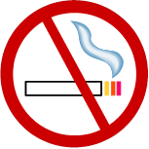

Examples of Prohibitory signs

Smoking prohibited | - We prohibit smoking in areas where smoking can cause fires, explosions and pollution (contamination) of foodstuff, etc.  - We prohibit fires and open lights in areas prohibited where these could cause fires and explosions.  - We prohibit pedestrians from entering or pedestrians walking through areas that are hazardous prohibited due to vehicle and equipment movements and also other areas such as security areas etc.  - We prohibit the use of water to extinguish of water as fires involving such things as “live” electrical extinguishing agent equipment, certain metals, etc., because doing this could either electrocute the person doing it or could cause an explosion or a violent chemical reaction or spread the fire.  - We prohibit the drinking of certain water of specific water because of impurities etc. This is usually supplies reclaimed water or the so-called “industrial” water, which is generally used for industrial purposes exclusively.  - We prohibit the entry of either vehicles proceeding.

Mandatory (must use)

- Shape: Circle (disc). Although round, still distinguishable from ring and triangle.
- Colour: Blue circle (disc).
- Pictogram: White

When people must enter an environment where hazards exist, certain protective equipment is MANDATORY.

Examples of mandatory signs

Eye Protection | To inform people that they must wear eye protection while in a certain area or while performing a certain task.
Respirators | To inform people that they must use respirators while in a certain area or performing certain tasks.
Hard Hats | To inform people that they must use hard hats while in certain areas or performing certain tasks involving falling items from above.
Ear Protection | To inform people that they must use ear protectors while within the confines of a “noise zone” (where the noise level exceeds 85 dB).

Informatory (general information)

- Shape: Square. Easily distinguishable from triangle, ring and circle.
- Colour: Green.
- Pictogram: White.

Basically there are two types of information signs and this particular type deals mainly with

GENERAL INFORMATION.

Informatory (fire equipment)

- Shape: Square. Easily distinguishable from triangle, ring and circle.
- Colour: White Square.
- Pictogram: Red.

This particular type of informatory sign deals particularly with the location of fire equipment.

Examples of mandatory signs
Shape: Circular  Colour: Blue  Pictogram: White  Vorm: Rond (skyf)  Kleur: Blou  Piktogram: Wit |  | 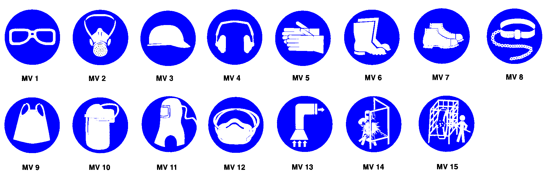
MV 1 | Eye protection shall be worn |  |  | MV 9 | Apron shall be worn
 | Oogbeskerming moet gerda word |  |  |  | Voorskoot moet gedra word
MV 2 | Respiratory protection shall be worn |  |  | MV 10 | Face protection shall be worn
 | Respiratoriese beskerming moet gedra word |  |  |  | Gesigbeskerming moet gedra word
MV 3 | Head protection shall be worn |  |  | MV 11 | Air-supplied hood shall be worn
 | Kopbeskerming moet gedra word |  |  |  | Kap met lugtoevoer moet gedra word
MV 4 | Hearing protection shall be worn |  |  | MV 12 | Dust mask shall be worn
 | Gehoorbeskerming moet gedra word |  |  |  | Stofmasker moet gedra word
MV 5 | Hand protection shall be worn |  |  | MV 13 | Air extraction shall be used
 | Handbeskerming moet gedra word |  |  |  | Afskerming moet gebruik word
MV 6 | Foot and leg protection against liquids shall be worn |  |  | MV 14 | Screening to be used
 | Voet-en beenbeskerming teen vloeistof moet gedra word |  |  |  | Afskerming moet gebruik word
MV 7 | Foot protection against crushing shall be worn |  |  | MV 15 | Use safety cage
 | Voetbeskerming teen vergruising moet gedra word |  |  |  | Gebruik veiligheidshok
MV 8 | Safety harnesses and lifelines shall be worn
 | Veiligheidsharnasse en reddingstoue moet gedra word

Examples of information, general signs
Shape: Square  Colour: Green  Pictogram: White  Vorm: Vierkant  Kleur: Groen  Piktogram: Wit |  | 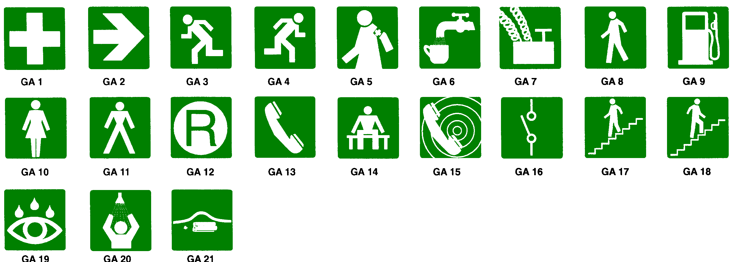
GA 1 | First-aid equipment |  | GA 8 | Travelling way | GA 15 | Emergency telephone
 | Noodhulptoerusting |  |  | Loopweg |  | Noodtelefoon
GA 2 | General direction |  | GA 9 | Refuelling point | GA 16 | Electric isolator switch
 | Algemene rigting |  |  | Brandstofpunt |  | Elektriese afsonderskakelaar
GA 3 | Direction to escape route |  | GA 10 | Ladies toilet | GA 17 | Stairs going down
 | Rigting na ontsnaproete |  |  | Dameskleedkamer |  | Trap na onder
GA 4 | Direction to escape route |  | GA 11 | Gents toilet | GA 18 | Stairs going up
 | Rigting na ontsnaproete |  |  | Manskleedkamer |  | Trap na bo
GA 5 | Manned first-aid station |  | GA 12 | Refuge chamber | GA 19 | Eye wash
 | Bemande noodhulppos |  |  | Skuilkamer |  | Oogspoelplek
GA 6 | Drinking water |  | GA 13 | Telephone | GA 20 | Safety shower
 | Drinkwater |  |  | Telefoon |  | Veiligheidstort
GA 7 | Blasting point |  | GA 14 | Waiting place | GA 21 | Location of bomb bag
 | Skietpunt |  |  | Wagplek |  | Houplek van bomsak

Examples of information, fire fighting signs
Shape: Square  Colour: White with red border line  Pictogram: Red  Vorm: Vierkant  Kleur: Wit met rooi buitelyn  Piktogram: Rooi |  | 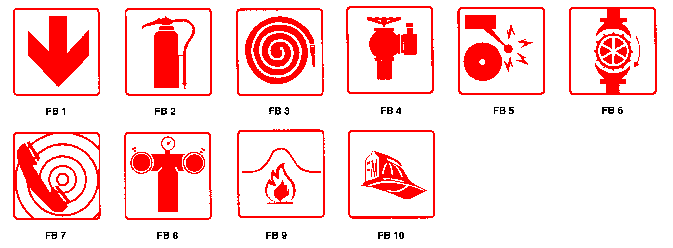
FB 1 | Location of fire-fighting equipment |  |  | FB 8 | Fire pump connection
 | Houplek van brandweertoerusting |  |  |  | Brandpompverbinding
FB 2 | Fire extinguisher |  |  | FB 9 | Location of fire blanket
 | Brandblusser |  |  |  | Houplek van brankombers
FB 3 | Fire hose |  |  | FB 10 | Fire Marshal
 | Brandslang |  |  |  | Brandweeraanvoerder
FB 4 | Fire Hydrant
 | Brandkraan
FB 5 | Fire alarm
 | Brandalarm
FB 6 | Sprinkler stop valve
 | Afsluitklep vir sprinkelblusser
FB 7 | Fire Telephone
 | Brandtelefoon

Examples of prohibitory signs
Shape: Circular  (annular or disc)  Colour: White with red border line  Pictogram: Red  Vorm: Vierkant  Kleur: Wit met rooi buitelyn  Piktogram: Rooi |  | 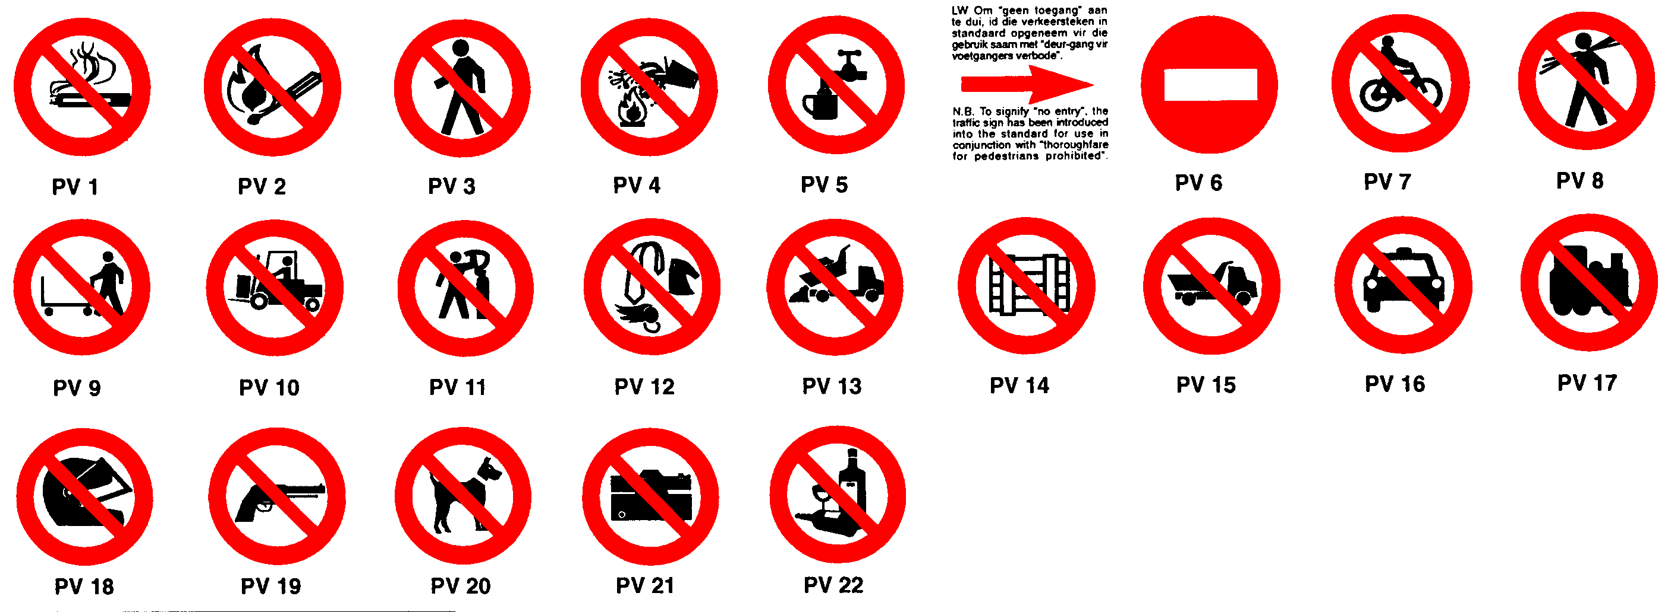
PV 1 | Smoking prohibited |  | PV 9 |  | Hand tramming prohibited |  |  | PV 17 |  | Locomotives prohibited beyond this point
 | Rook verbode |  |  |  | Handtremwerk verbode |  |  |  |  | Lokomotiewe verby hierdie punt verbode
PV 2 | Fire and open flames prohibited |  | PV 10 |  | Tractors and fork-lifts prohibited beyond this point |  |  | PV 18 |  | Wearing of safety helmets prohibited
 | Vuur en oop vlamme verbode |  |  |  | Trekkers en vurkhyswaens verby hierdie punt verbode |  |  |  |  | Dra van veiligheidshelms verbode
PV 3 | Thoroughfare for pedestrians prohibited |  | PV 11 |  | Use of compressed air to dust body prohibited |  |  | PV 19 |  | Carrying of fire-arms prohibited
 | Deurgang vir voetgangers verbode |  |  |  | Gebruik van druklug vir skoonblaas van liggaam verbode |  |  |  |  | Dra van vuurwapens verbode
PV 4 | Water as extinguishing agent prohibited |  | PV 12 |  | Loose clothing, ties, jewellery and confined long hair prohibited |  |  | PV 20 |  | Dogs prohibited
 | Water as blusmiddel verbode |  |  |  | Los kledingstukke, dasse, juwele en los lang hare verbode |  |  |  |  | Honde verbode
PV 5 | Drinking of this water is prohibited |  | PV 13 |  | Dumping prohibited |  |  | PV 21 |  | Cameras prohibited
 | Drink van hierdie water verbode |  |  |  | Storting verbode |  |  |  |  | Kameras verbode
PV 6 | Proceeding beyond this point prohibited |  | PV 14 |  | Do not obstruct |  |  | PV 22 |  | Alcohol prohibited
 | Toegang verby hierdie teken verbode |  |  |  | Moenie versper nie |  |  |  |  | Alkohol verbode
PV 7 | Cycling prohibited |  | PV 15 |  | No entry for heavy vehicles
 | Fietsry verbode |  |  |  | Geen toegang vir swaar voertuie nie
PV 8 | Carrying of long material prohibited |  | PV 16 |  | No entry for vehicles
 | Dra van lang voorwerpe verbode |  |  |  | Geen toegang vir voertuie nie
Shape: Triangular  Colour: Black border, yellow centre  Pictogram: Black  Vorm: Driehoekig  Kleur: Swart rand, geel binnekant  Piktogram: Swart |  | 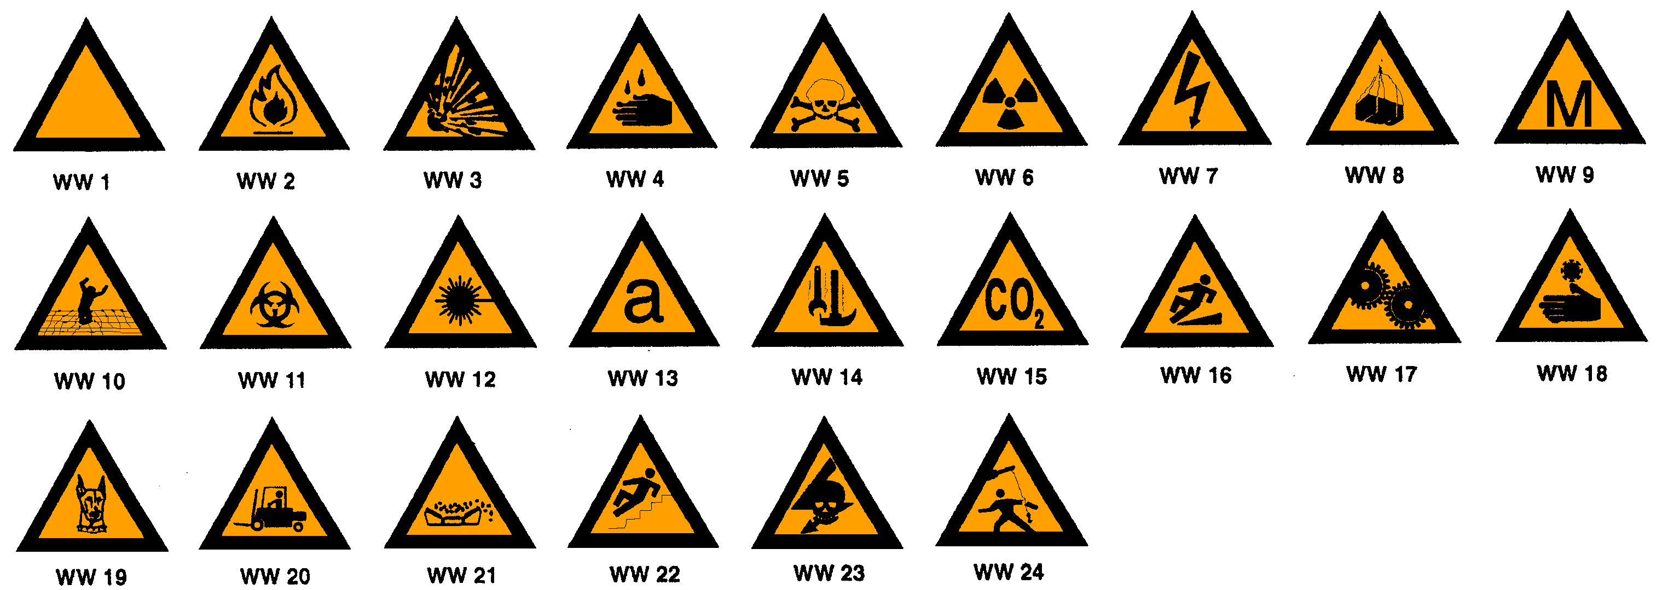
WW 1 | General warning of hazard |  |  | WW 10 |  | Warning of fragile roof | WW 19 |  | Beware of dogs
 | Algemene waarskuwing teen gevaar |  |  |  |  | Waarskuwing teen breekbare dak |  |  | Pasop vir honde
WW 2 | Warning of fire hazard |  |  | WW 11 |  | Warning of biological hazard | WW 20 |  | Beware of fork-lifts
 | Waarskuwing teen brandgevaar |  |  |  |  | Waarskuwing teen biologiese gevaar |  |  | Pasop vir vurkhyswaens
WW 3 | Warning of explosion hazard |  |  | WW 12 |  | Warning of laser hazard | WW 21 |  | Beware of material falling from moving conveyor belt
 | Waarskuwing teen plofgevaar |  |  |  |  | Waarskuwing teen laser |  |  | Pasop vir materiaal wat van bewegende vervoerbank
WW 4 | Warning of corrosion hazard |  |  | WW 13 |  | Warning of asbestos hazard |  |  | kan val
 | Waarskuwing teen korrosiegevaar |  |  |  |  | Waarskuwing teen asbes | WW 22 |  | Warning of hazard of slippery steps
WW 5 | Warning of poisonous substances hazard |  |  | WW 14 |  | Warning of workers overhead |  |  | Waarskuwing teen gevaar van glibberige trap
 | Waarskuwing teen gevaar van giftige stowwe |  |  |  |  | Waarskuwing teen werkers bo | WW 23 |  | Warning of hazard of exposed live highvoltage
WW 6 | Warning of ionizing radiation hazard |  |  | WW 15 |  | Warning of carbon dioxide hazard |  |  | equipment
 | Waarskuwing teen ioniseerstralingsgevaar |  |  |  |  | Waarskuwing teen koolstofdioksiedgevaar |  |  | Waarskuwing teen gevaar van onbedekte lewendige
WW 7 | General warning of electric shock hazard |  |  | WW 16 |  | Warning of hazard of slippery walking surface |  |  | hoëspanningstoerusting
 | Algemene waarskuwing teen gevaar van elektriese skok |  |  |  |  | Waarskuwing teen gevaar van glibberige loopvlak | WW 24 |  | Warning of hazard of swinging beam
WW 8 | Warning of suspended loads hazard |  |  | WW 17 |  | Warning of hazard of moving machinery |  |  | Waarskuwing teen gevaar van swaaiende balk
 | Waarskuwing teen gevaar van hangende laste |  |  |  |  | Waarskuwing teen gevaar van bewegende masjinerie
WW 9 | Warning of methane hazard |  |  | WW 18 |  | Warning of hazard of cold burns
 | Waarskuwing teen metaangevaar |  |  |  |  | Waarskuwing teen gevaar van kouebrandwonde

Warning Sign

